Ryan Barber Assignment 9.2 2/28/2026
API test screenshot:
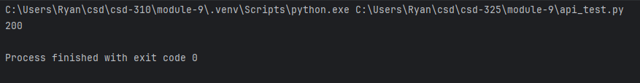
API astronaut screenshots:
Raw format -
Formatted -
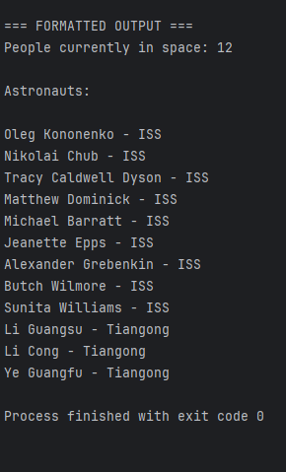
Star Wars Films API:
Raw format -

Formatted –
